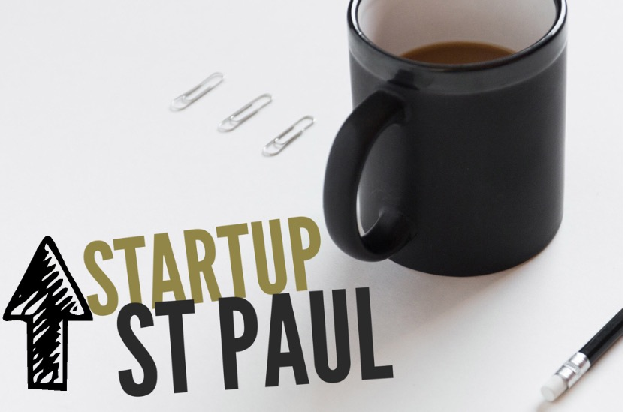

*2017Challenge*

**Application**

Return applications to: Kathy Stewart, St. Paul Main Street, P.O. Box 818, St. Paul, VA 24283, 276 395.0685. Applications will be accepted through March 15th by 11:59 p.m. or postmarked by that date. Applications can be submitted via email, postal mail. For questions regarding the program or application, please contact Kathy Stewart at stpaulmainstreet@gmail.com

Name of Applicant: Click here to enter text.

Name of business, if applicable: Click here to enter text.

Address: Click here to enter text.

City/Town:Click here to enter text. State:Click here to enter text. Zip code:Click here to enter text.

Home phone:Click here to enter text. Cell phone:

Email:Click here to enter text.

Website: Click here to enter text.

Which eligible category most closely describes your business? (Choose One)

Arts and Culture – emphasis on products or offerings that value handmade, authentic and distinctive of the Southwest Virginia culture

Outdoor Recreation – emphasis on products or offerings that promote, showcase, or make use of natural assets and outdoor opportunities

General Retail - clothing, gifts, hardware, antiques, specialty items, etc.

Restaurant and Hospitality – emphasis on services that provide meals, lodging, or other guest services that enhance the visitor and/or tourist experience

Technology/ Advanced Manufacturing – emphasis on industries that use advanced technology to improve their products or services

Other and Support Services/None of the above – emphasis on activities that support any of the above categories

Please answer the following questions about your business. Limit all responses to 2-3 paragraphs, however, provide enough detail so that your answers can be evaluated thoroughly.

1. Describe your business or business concept. Provide enough description to explain to someone unfamiliar with your business would know what you are offer and how it benefits customers. Include how this business or business concept is unique from current offerings in the region.

Click here to enter text.

1. How does your business or business concept fit into the above eligible categories? How does it fit into the local and regional strategies and initiatives of Southwest Virginia?

Click here to enter text.

1. How would participation in this program help you launch, expand, or develop your business?

Click here to enter text.

1. Attach a current copy of your résumé.

By checking this box, I understand that I may/may not be selected to participate in the Entrepreneur Challenge which offers training, networking opportunities and potential monetary awards. If selected to participate in the program, I will attend scheduled trainings and events and participate as an engaged member of the group. If my business or business idea is selected as an award winner, once I establish an eligible business within the eligible region, I will use the funds for qualified business expenses.

Schedule of Events for StartUP St. Paul

|  |  |
| --- | --- |
| Date | Topic Covered |
| February 1, 2017 | Applications available |
| March 15, 2017 | Applications due |
| March 21, 2017 | Cohort announced |
| April 4, 2017 | Rules – Intro to Business – Meet and Listen to Jennifer Bailey of Sugar Hill Brewery. |
| April 11, 2017 | Managing a Business - Credit Info for Start-up and ongoing needs. |
| April 18, 2017 | Expert Panel Discussion / Finance, Legal, Accounting, Insurance. |
| April 25, 2017 | Marketing / Social Media - Guest Speakers |
| May 2, 2017 | |  | | --- | | Hospitality & Customer Service | |
| May 9, 2017 | “Pitch” Night |
| May 16, 2017 | Business Plan Due |
| June 1, 2017 | Winners Announced |

Accepted Challenge area is Commercial zoned area of St. Paul. (See Map)

*2017 StartUP St. Paul*

**Frequently Asked Questions**

1. When will the winners of the cohort be announced?

*Winners will be announced on June 1st 2017 at the Railroad Museum and Gallery on Russell St. during Clinch River Days Festival.*

1. Where will the classes be located? What is the timeframe for the classes? Who will be facilitating the classes?

*The classes will be located at the St. Paul Recreation Rooms. The Address is 16550 Tazewell St., St. Paul, VA 24266. The classes will start approximately at 6:00 and end at 8:30. Professional and Experienced Trainers will be the lead facilitators. They have a wealth of knowledge and experience in business start-ups and expansions.*

1. Do I have to attend all of the classes?

*You are required to attend all classes in the program to qualify for the awards.*

1. If my business does not fit into on the set categories am I still eligible for the prize money?

*The set categories are the priority areas for investment. This is the first StartUP Challenge for St. Paul, so we cannot firmly say that prize dollars won’t be invested in other categories, However, the award jury reserves the right to not award all of the prize money.*

1. Do I have to have a business plan to start the cohort?

*No, you are not required to have a business plan when you start the challenge. The courses will cover how to write a business plan and what information should be in the plan. If you already have a plan, you will use this a time to refine it and perhaps tailor it to fit.*

1. What are the requirements to be accepted into the cohort?

*You should expect to locate your business in St. Paul. Your completed application will also be reviewed for appropriateness of participation in the program.*

1. What are the requirements to win the prize money? DID WE DISCUSS THIS??

*You will be required to actually establish a business in St. Paul and begin operations by June 1st, 2018. The award jury reserves the right to not award all of the prize money.*

1. Is anyone ineligible to apply for the challenge?

*You don’t have to currently live in the region, but you should have an interest in investing in the St. Paul Community.* ***Units of local government are not eligible applicants****.*

1. What can the prize money be used for?

*The prize money can be used for any demonstrated business related expense. A receipt or statement is required for documentation.*

1. What documentation do I need to provide to show the money is being used for my business?

*A receipt or statement is required to withdraw the money from the StartUP account*

1. Is there anything required of me if I win the money?

*The only requirement is that you locate your business within the Town of St. Paul and use the money for a valid business expense. We request that you allow us and the Business Challenge partners to share your success story with the media and we may ask you to present at similar challenges in the future.*

1. Is there a set time that I must use all of the money?

*If the money is not invested in a business by June 1, 2018. It will be forfeited. The St. Paul StartUP Challenge steering committee reserves the right to extend this deadline, if appropriate.*

1. What do you hope to accomplish from this challenge?

*We hope to inspire and assist entrepreneurs and small business owners in realizing their dream. This will increase jobs and revenue in St. Paul, which is beneficial for all involved.*

*Map of St. Paul*

**